Latest Round-ups:
Season 2019/20
#4
Midweek Action: On Monday evening, Calne Town rebounded from their defeat to Cheddar with a 5-0 victory over early season First Division strugglers Hengrove at Bremhill View. The hosts led by two at the break, with Josh Hard opening the scoring, before leading scorer Stuart Windsor doubled their tally with a tap in. The Lilywhites pushed on in the final 20 minutes, with Windsor adding two more goals to complete his hat-trick, either side of an effort from strike partner Jake Allen.

With a full set of midweek fixtures in the Premier Division, Bradford Town continued their winning start to the season with a 2-0 triumph away at Chipping Sodbury Town thanks to goals from Neikell Plummer and Gary Higdon. There was also a victory for Keynsham on Tuesday evening, with new signing Ben Dowdell and Harley Purnell both on the scoresheet during their 2-1 win over Roman Glass St George. Another brace from Jack Fillingham helped Shepton Mallet maintain their unbeaten league start with a 3-0 win away at Bridport, while Street defeated Wellington 4-2 thanks to goals from Leighton Thomas, Kameron Andrews and Kyle Strange (x2). The game of the night came at Ironmould Lane where Brislington propelled a second half fightback from Cadbury Heath to gain a 4-3 victory. Having fallen behind to Matt Huxley’s 12th minute opener, the home side hit back from the spot through Mike Rimmer before Jayden Nielson completed the turnaround 15 minutes later. An own goal just prior to half-time extended Brislington’s lead, with the Heath then drawing level thanks to goals from Eli Nicholls and Enis Akgun. The game wasn’t level for long however, and less than three minutes after conceding, Mason Dagger struck the seventh and final goal of the contest to hand Brislington all three points. Bitton returned to winning ways on the road at Cribbs, where a hat-trick from Josh Egan, and a double from Tristan Plummer fired them to a commanding 6-0 success.

24 hours later, all eyes were on Devon, with a pair of derbies taking place between a number of the early-season pacesetters. At Bolitho Park, a big crowd of 308 were in attendance to watch Plymouth Parkway defeat Exmouth 1-0. Both sides had won three from three heading into the fixture, but it was Parkway who maintained their winning start with a 26th minute goal from Adam Carter handing them victory by the narrowest of margins. There was a more one-sided affair at Langsford Park, where Liam Prynn smashed in four goals to power Tavistock to a 5-0 thrashing of Buckland Athletic. Elsewhere on Wednesday, strikes from Elliott Nicholson, Zach Drew and Lucas Vowles led Clevedon to a 3-1 win over Odd Down, while two goals in the final five minutes from Troy Simpson and sub Rob Latham completed Hallen’s 3-1 come-from-behind victory away at Westbury.
FA Cup: Bradford Town were one of three Western League sides to knock out higher-ranked opposition in the extra-preliminary round of the FA Cup, scoring a 3-1 win over Larkhall Athletic. Going up against his former employers, Bradford manager Wayne Thorne saw his side enjoy the best of the first half, with Tyson Pollard giving them a deserved lead. It took no time at all for the hosts to double their advantage after the interval with Gary Higdon netting from a tight angle, before Lewis Powell struck from the spot to hand the Bath-side a lifeline. The Bobcats added the finishing touches to their victory late on, with Matt Morris adding a third during the final ten minutes. Tavistock’s promising start to the season continued on Saturday afternoon, with the Lambs registering a 2-1 win over Southern League side Frome Town. A penalty from Jack Crago had put the home side ahead, before the Somerset side hit back through former-Bradford frontman Will Hailston. With time running out, Luke Brown scored the third and final goal of the contest to book Tavistock’s passage through to the next round where they will be joined by Plymouth Parkway who thumped Paulton Rovers 5-2. Having fallen two goals behind following Ed Butcher’s brace, two crucial strikes in the closing stages of the first half from Shane Krac and Billy Palfrey got Parkway level. The Devon outfit then pushed on during the second half, with a Jordan Copp penalty putting them ahead for the first time, before late goals from Mike Williams and Palfrey wrapped up a highly-impressive comeback. Bridgwater Town also waltzed through to the next round, after hat-tricks from strike duo Steve Murray and Jack Taylor saw them demolish Brislington by seven goals to nil at Fairfax Park. Shepton Mallet came within minutes of claiming a famous victory over Melksham, and will instead face a replay following their 1-1 draw. After skipper Liam Watson had nodded them ahead towards the back-end of the first half, Shepton were closing in on victory before Jack Ball converted a penalty four minutes from time to set up a return meeting. Exmouth will also face a replay after twice relinquishing the lead during their 2-2 draw away at Yate Town. Goals in either half from Aaron Denny and Jordan Harris had twice put the visitors on track for the win, but Yate managed to salvage a draw thanks to a pair of equalisers from Olly Mehew. Two goals from George King weren’t enough for ten-man Clevedon Town who were handed a 5-2 defeat at home to Bristol Manor Farm, while Cribbs suffered late heartbreak, conceding five minutes from time in their 1-0 loss against Bideford. In a meeting between the two previous Western League champions, Willand were much too strong for Street, with a double from Luke Mortimore leading Rovers to a 5-1 triumph at Silver Street.
Action from Bradford Town’s 2-1 victory in the FA Cup against Larkhall Athletic, courtesy of John Pool.

Roman Glass St George were also knocked out at the hands of Didcot, while Bitton were denied at the death by Mangotsfield Town. Having led 2-1 earlier in the contest, Bitton couldn’t keep the Mangos at bay, and saw their cup dreams disappear in the dying minutes when Ben Brooks struck to cap the visitors 3-2 win.
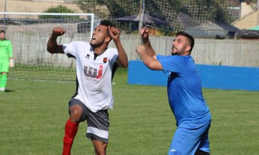
Premier Division: Odd Down’s promising start to the campaign continued in Bath, after they secured a 3-1 victory over Wellington. The home side made a brilliant start to the game, leading by two goals inside the opening eight minutes thanks to a Jay Murray header, and then a cross-come-shot from 40 yards by Josh Cann. Wellington gained a foothold just after the half-hour mark when Carl Jones was hauled down in the penalty area, with Jack Bryant smashing home the resulting spot kick with aplomb. 20 minutes from time, Odd Down made sure of victory, when James O’Kell drove the ball home from outside the area, handing Welly their fourth successive defeat in the process. Buckland Athletic responded to a heavy midweek defeat by beating Chipping Sodbury Town 4-0 at Homers Heath. The result was potentially a little unjust owing to three goals in the final quarter-hour, but nothing should be taken away from the performance of Ryan Bush, with the Buckland forward grabbing a hat-trick before Dan Gaze added a late fourth. In the other Premier Division contest, Bridport gained a much-needed morale boost, with a stoppage time goal handing them a 2-1 victory away at Cadbury Heath.
Action from Odd Down’s 3-1 victory over Wellington.
First Division: Cheddar maintained their 100% record in the First Division this season thanks to a 3-1 win away at Lebeq United. Adam Wright was amongst the goals once again for the Cheesemen, with a brace from Stephen Pennington completing the scoring for the away side at Oaklands Park. Calne Town have also enjoyed a strong start to their campaign, with their 2-0 win over Bishop Sutton making them the first side to reach double figures. Six minutes into the second half, Calne went ahead through a usual suspect, with Josh Hard scoring for the fourth consecutive fixture before the prolific Stuart Windsor wrapped victory up five minutes from time with a belting finish. A hat-trick from Toby Dolton Cole fired Wincanton to a 5-2 victory over the winless Devizes Town. Having watched teammate Dan Wise tuck home two first half penalties, Cole grabbed his first goal of the game 15 minutes from time to seemingly kill off the game. Devizes had other ideas though, and set up a potentially tense finale thanks to a pair of quick-fire goals from Matt Russell and Jamie Wallen. Those goals seemed to kick-start the home side back into life, and after Cole put them two goals to the good, the same man then popped up once more in injury time to complete his goalscoring treble.
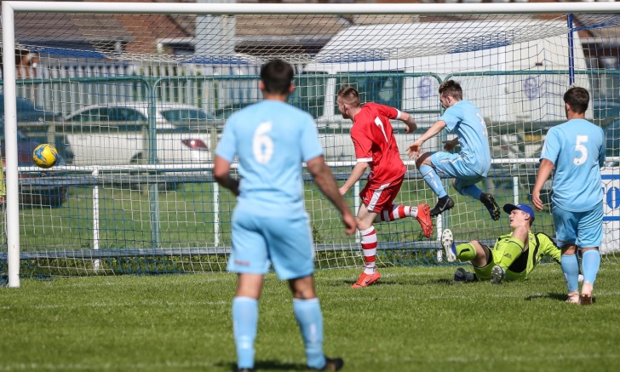
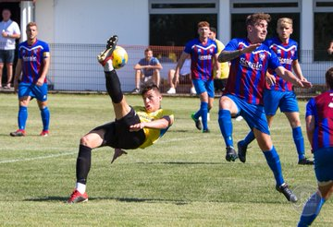
After losing their opening game, Sherborne have now reeled off three successive victories, with their latest three points coming away at Bishops Lydeard by three goals to one. Sam Carney, Anthony Herrin and Haydn Hodges all got on the scoresheet for the Zebras at Cothelstone Road, with Mark Cornish notching a consolation for Lydeard who have now lost each of their home fixtures. Bristol Telephones were another side to lose at their home ground, after Josh Bright and Leigh Rogers each scored twice during Corsham Town’s 4-2 victory. Warminster went one better than Corsham, defeating Portishead Town 5-2 at Bristol Road. The Wiltshire side were rampant in the early stages, making their dominance pay twice inside the opening 20 minutes thanks to goals from Jack Miluk and Charlie Walton. It was then James Vincent’s chance to get in on the goalscoring action at the beginning of the second half, with Portishead pulling a goal back before Vincent and Walton added to their tallies in the space of a minute to put the result beyond doubt. An improved defensive showing from Hengrove helped them scrape a 0-0 draw away at Almondsbury, while goals from Paul Uppington, George Jones and Joe Bishop saw Ashton & Backwell United register a 3-2 win at home to Longwell Green Sports. A goalscoring double from Joe Beardwell helped Oldland Abbotonians overturn an early deficit in their 2-1 win away at Welton Rovers. The Green Army made a dream start at West Clewes, with Lewis Coleman grabbing an opener after just four minutes following a well struck half volley. The second half belonged exclusively to Beardwell, with the Abbots marksman levelling things five minutes after the restart before he scored a dramatic 89th minute winner thanks to a fine finish from the edge of the area. Wells City have now won three away league games already this season after a first-half double from Charlie Crook handed them a 2-1 victory over Radstock.
Action from Ashton & Backwell’s 3-2 victory over Longwell Green, courtesy of James Healey.
Leigh Rogers opens the scoring for Corsham during their win over Bristol Telephones. Image courtesy of John Cuthbertson.
Be sure to check out the latest podcast, where Ian, Tom & guests recap all the latest news and results from around the Western League. To follow along all season, each broadcast will be available at the following link: http://www.toolstationleague.com/podcasts.php

Latest Results
Monday 19th August 2019
First Division
Calne Town 5-0 Hengrove Athletic 108
Tuesday 20th August 2019
Premier Division
Bridport 0-3 Shepton Mallet 151
Brislington 4-3 Cadbury Heath 92
Chipping Sodbury Town 0-2 Bradford Town
Cribbs 0-6 Bitton 83
Keynsham Town 2-1 Roman Glass St George 101
Street 4-2 Wellington 122
First Division
Devizes Town A-A Welton Rovers
Wednesday 21st August 2019
Premier Division
Clevedon Town 3-1 Odd Down 108
Plymouth Parkway 1-0 Exmouth Town 308
Tavistock 5-0 Buckland Athletic 102
Westbury United 1-3 Hallen 101
Saturday 24th August 2019
FA Cup – Preliminary Round
Bitton 2-3 Mangotsfield Town 170
Bradford Town 3-1 Larkhall Athletic 171
Bridgwater Town 7-0 Brislington 181
Clevedon Town 2-5 Bristol Manor Farm 172
Cribbs 0-1 Bideford 88
Didcot 2-1 Roman Glass St George
Plymouth Parkway 5-2 Paulton Rovers 184
Shepton Mallet 1-1 Melksham Town 196
Street 1-5 Willand Rovers 149
Tavistock 2-1 Frome Town 101
Yate Town 2-2 Exmouth Town
Premier Division
Buckland Athletic 4-0 Chipping Sodbury Town 82
Cadbury Heath 1-2 Bridport 45
Odd Down 3-1 Wellington 42
First Division
Almondsbury 0-0 Hengrove Athletic 37
Ashton & Backwell United 3-2 Longwell Green Sports 45
Bishops Lydeard 1-3 Sherborne Town
Bristol Telephones 2-4 Corsham Town 55
Calne Town 2-0 Bishop Sutton 85
Lebeq United 1-3 Cheddar
Portishead Town 2-5 Warminster Town 38
Radstock Town 1-2 Wells City 58
Welton Rovers 1-2 Oldland Abbotonians 79
Wincanton Town 5-2 Devizes Town 63

Upcoming Fixtures
Saturday 31st August 2019 (KICK OFF AT 3.00PM UNLESS NOTED)
FA Vase – First Qualifying Round
Almondsbury vs Buckland Athletic
Andover Town vs Westbury United
Bashley vs Bridport
Bishops Lydeard vs Bodmin Town
Bristol Telephones vs Falmouth
Cadbury Heath vs Longwell Green Sports
Calne Town vs Downton
Clevedon Town vs Roman Glass St George
Devizes Town vs Stockbridge
Exmouth Town vs Brislington
Hengrove Athletic vs Radstock Town
Ivybridge Town vs Bishop Sutton
Keynsham Town vs Helston Athletic
Launceston vs Cheddar
Odd Down vs Portishead Town
Shepton Mallet vs Wellington
Solent University vs Bradford Town
Street vs Crediton United
Tavistock vs Hallen
United Services Portsmouth vs Sherborne Town
Wells City vs Millbrook
Welton Rovers vs Newton Abbot Spurs
Wokingham & Emmbrook vs Chipping Sodbury Town
Premier Division
Bridgwater Town vs Plymouth Parkway
First Division
Oldland Abbotonians vs Corsham Town

